**GIT-HOL ASSIGNMENT-3** (3 pages)

**Branching in Git**

Branching in Git allows you to create a separate line of development, isolated from the main branch (usually main or master). This helps in working on features or fixes without affecting the stable code.

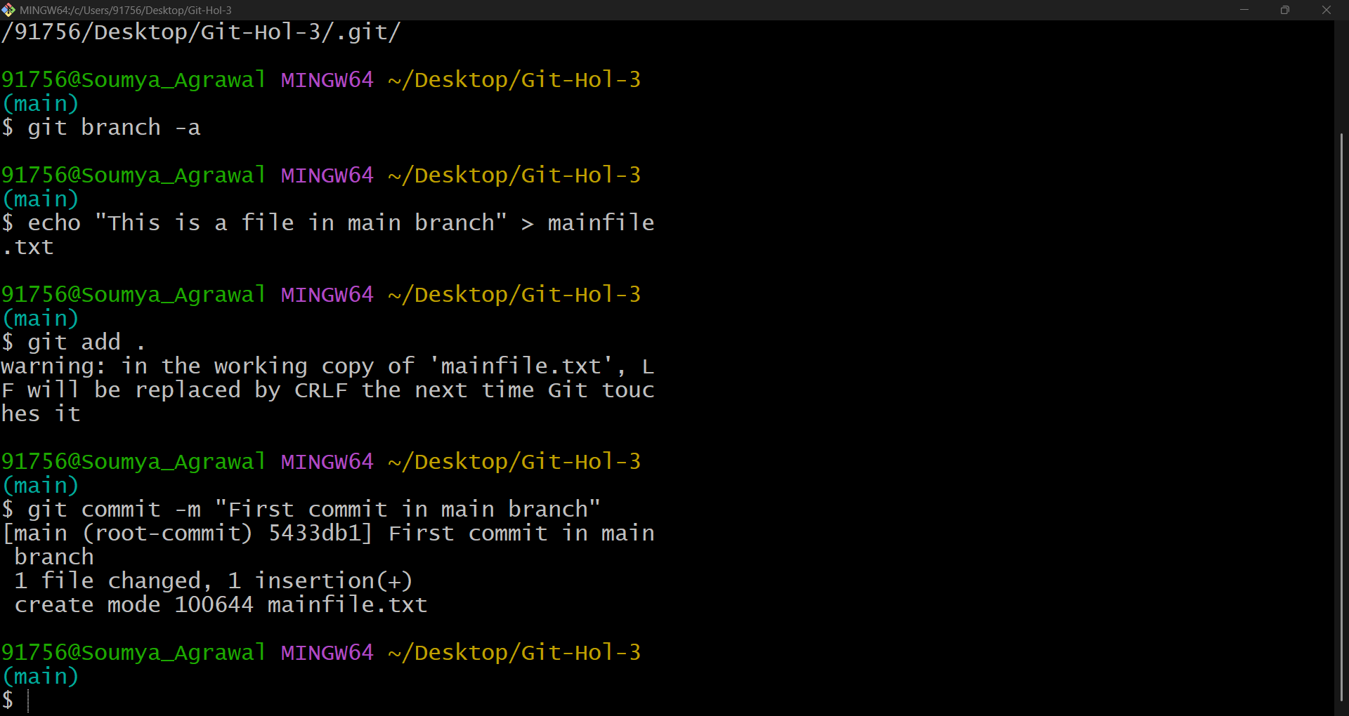

**Figure 1: Commit in main branch**

**Merging in Git**

Merging is the process of integrating changes from one branch into another.

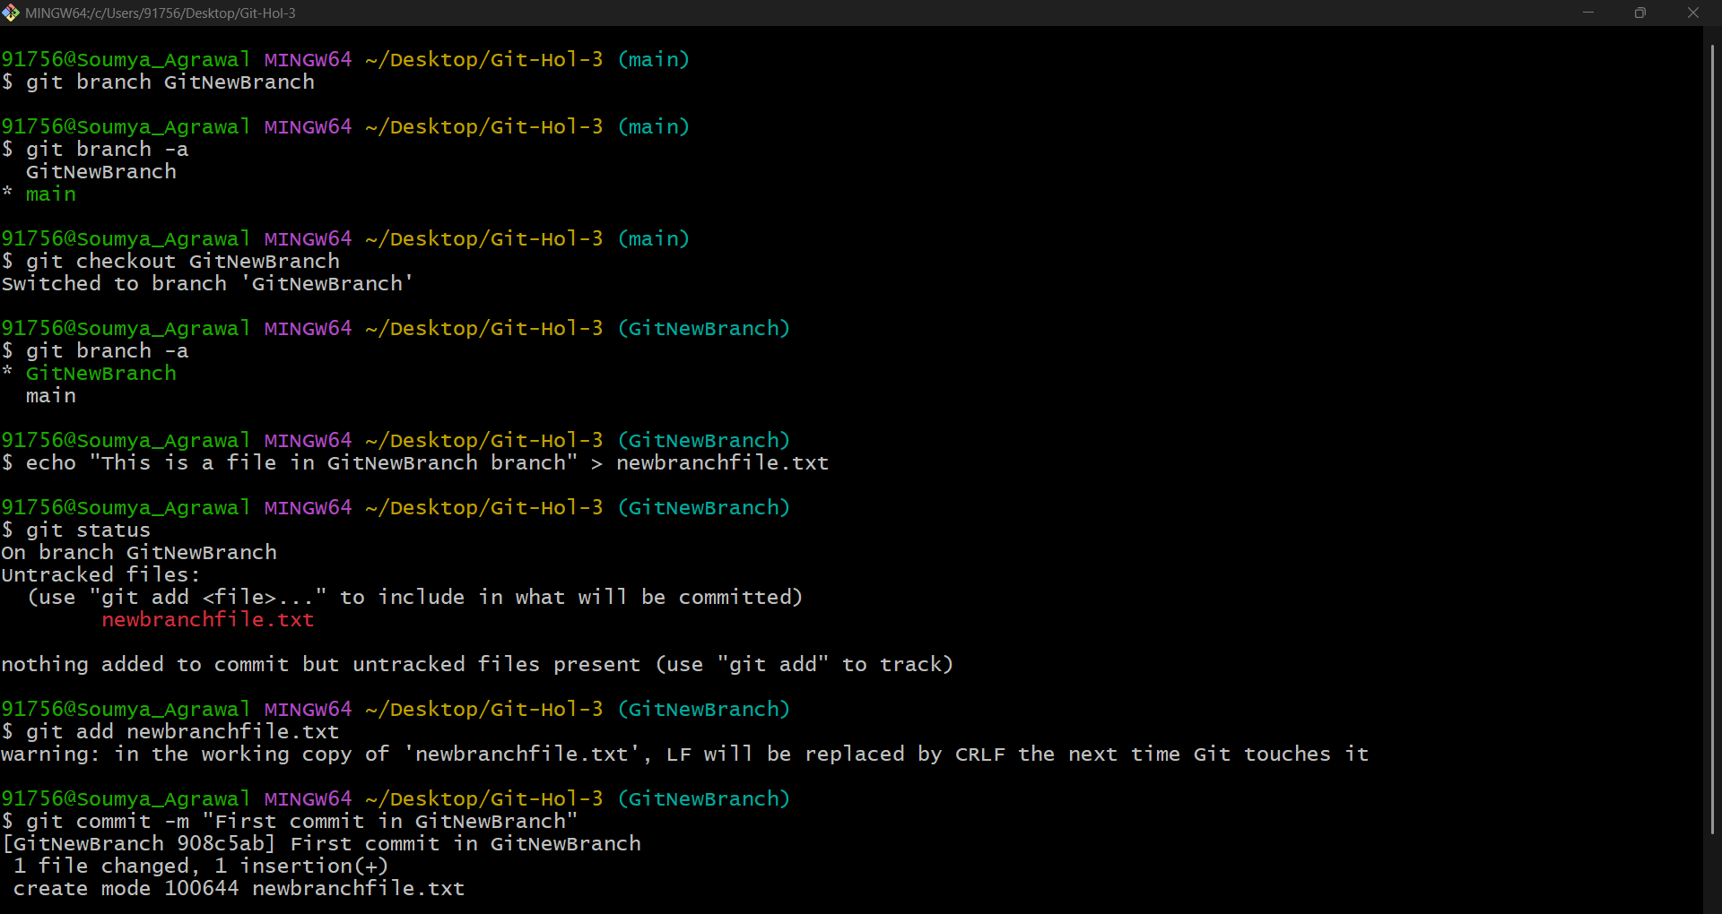

**Figure 2: Commit in new branch GitNewBranch**

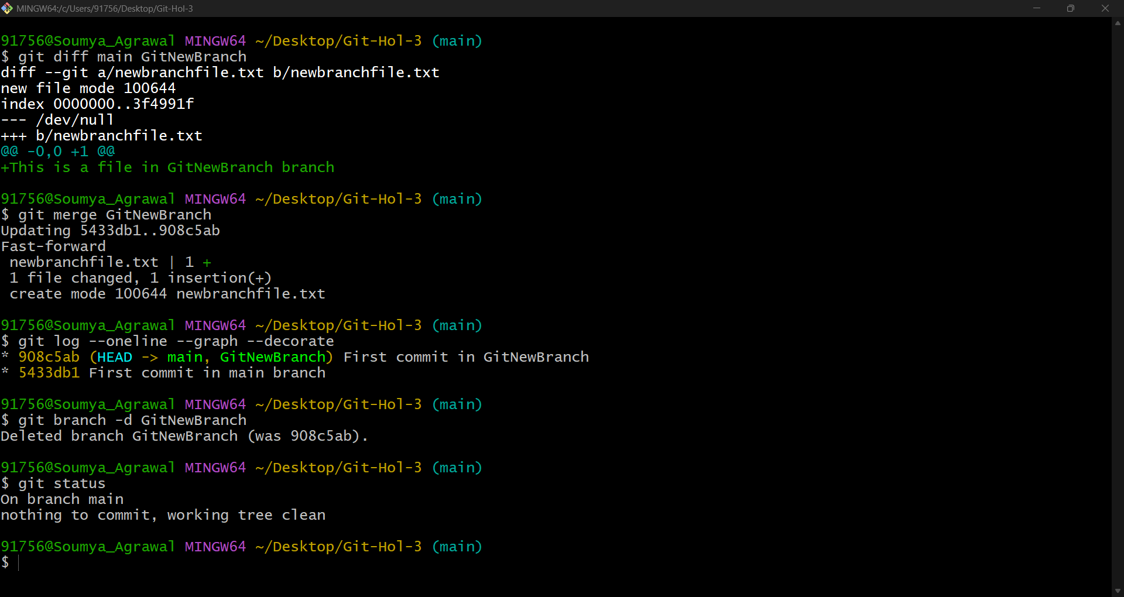

**Figure 3: Difference between two branches, merged differences and deleted the newly created branch GitNewBranch.**